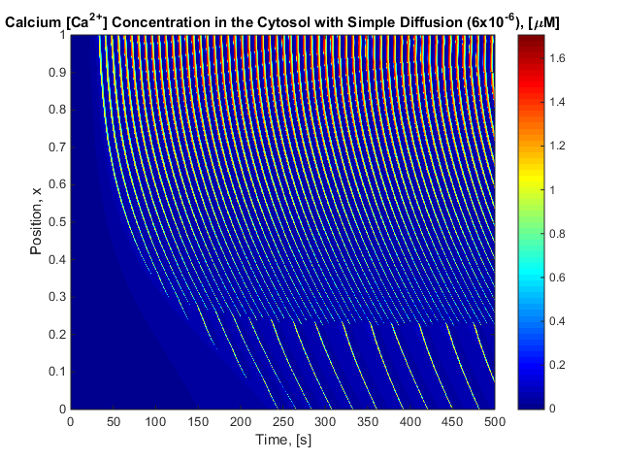 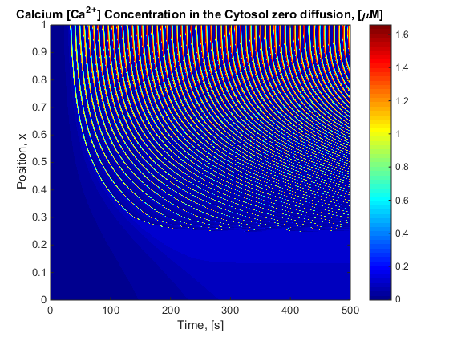 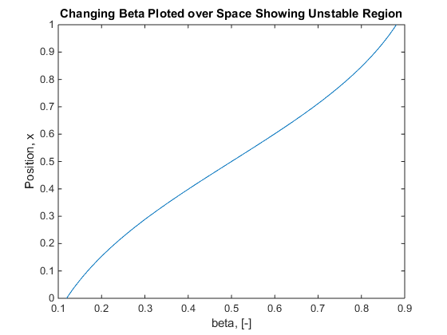

malpha_2 = mbeta;

%% Constants

mdelta = 0.01;

mgamma = 5.405;

malpha = 0;

malpha_1 = 1;

% malpha_2 = 0.2;

mbeta = 0.08;

tou_n = 12.5; % I made this up based on other

k_flux = 6.0;

V_p = 24;

k_p = 0.4;

V_e = 20;

k_e = 0.06;

k_1 = 1.1;

k_2 = 0.7;

k_mu = 4;

mu_0 = 0.567;

mu_1 = 0.433;

b = 0.111;

V_1 = 0.889;

k_4 = 1.1;

% %% Fluxes

J_release = (k_flux.*(mu_0 + mu_1*P./(k_mu+P)).*N.*(b+ V_1*C./(k_1 + C))).*(Ce-C);

J_serca = V_e* C./(k_e+C);

% J_in = malpha_1+v.*malpha_2./mbeta;

J_in = malpha_1+malpha_2.*P;

J_pm = V_p*(C.^2./(k_p^2+C.^2));

%% Differential Equations

L_C = J_release - J_serca + mdelta*(J_in - J_pm);

L_Ce = mgamma*(J_serca - J_release);

L_N = (1/tou_n).*((k_2^2)./(k_2^2+C.^2)-N);

L_P = v.*((C+(1-malpha)*k_4)./(C+k_4))-mbeta.*P;